[Monday 14:36] Michael Tint

Salesforce: <https://flextrade.lightning.force.com/lightning/>  
MaxxTrader Salesforce: <https://maxxtradesystems.lightning.force.com/lightning>  
Jira: <https://support.eu.flextrade.com/secure/Dashboard.jspa>  
BambooHR: flextrade.bamboohr.com/home  
ADP: <https://myapps.microsoft.com/signin/f5c974c2-a7eb-42f7-83ac-bf8c69d9b1c9?tenantId=9205318c-614c-4cba-9583-180aecbeb773>  
Linked vCenter: <https://ld4-vcenter.chicago.flextrade.com/ui/>  
LDN1 vCenter: <https://ldn1-vcenter.london.flextrade.com/ui/#?extensionId=vsphere.core.inventory.serverObjectViewsExtension&objectId=urn:vmomi:Folder:group-d1:a84b79a8-c64d-41da-bed9-5fc4a82641f7&navigator=vsphere.core.viTree.hostsAndClustersView>  
IPAM: <https://ipam.london.flextrade.com>  
Citrix Cloud: <https://xenapp.cloud.com/manage/webstudio>  
Jenkins: <https://k8s-its-jenkins1.london.flextrade.com>  
Opsgenie (you won't yet have access): <https://flextradeuk.app.opsgenie.com/alert/list>  
CyberArk: <https://sl1-ark-01.flextrade.com/PasswordVault/v10/logon/radius>

[Monday 15:08] Michael Tint

[Monday 15:08] Michael Tint

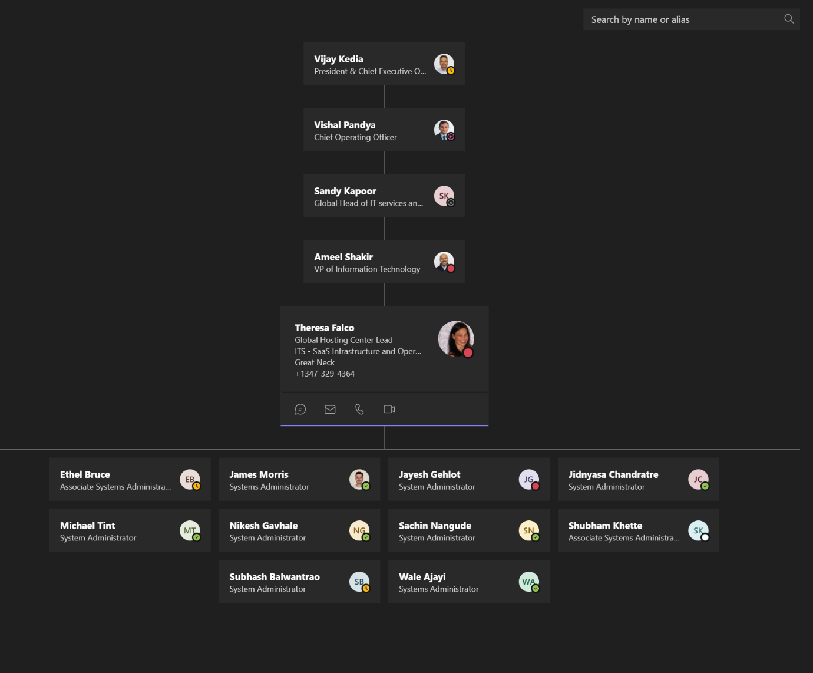

[Monday 15:08] Michael Tint

[Org Chart (bamboohr.com)](https://flextrade.bamboohr.com/employees/orgchart.php?pin)

Sign in to your account

[Monday 16:02] Michael Tint

SolarWinds: <https://ny4-flex-solar.flexwin.intranet.flextrade.com/Orion/Login.aspx?ReturnUrl=%2f>  
PRTG: <https://prtg1.eu.flextrade.com/public/login.htm?loginurl=%2Fwelcome.htm&errorid=0>  
Puppetboard: flxsglpuppet.singapore.int  
UK App: <https://uk-app.flextrade.com/logon/LogonPoint/tmindex.html>  
AMS Prod App: <https://ny4p.flextrade.com/Citrix/flexprodWeb/>  
AMS Demo App: <https://ny4d.flextrade.com/Citrix/flexdemoWeb/>

[Monday 16:03] Michael Tint

Nagios: <http://nagios.hosted.eu.flextrade.com/>  
SecretServer: <https://secretserver.flextrade.com/SecretServer/Login.aspx>

[Monday 16:05] Michael Tint

[NetScaler AAA (flextrade.com)](https://uk-app.flextrade.com/logon/LogonPoint/tmindex.html) login with Chicago uid/pw

[Monday 16:16] Michael Tint

Chicago.flextrade.com

User id - mtint

Password – AmyWini3wicz1998!!

[Monday 16:38] Michael Tint

Cahahak@2022!!

[Monday 16:39] Michael Tint

MTCah4hak@2022#!

[Monday 16:39] Michael Tint

[Citrix Receiver (flextrade.com)](https://uk-app.flextrade.com/Citrix/FlexTradeWeb/)  using

Chicago.flextrade.com

User id - mtint

Password – W3lcome123!@#

[Monday 16:57] Michael Tint

601230d34ebaa981  
2c62ba86e5fe0d3e  
2ac2fe067081d903  
ad6bc635d49c68e8  
3e78fffe83bb96c4  
81beada1797c1a73  
65a6b54e8968c3c4  
354356faafea46bb  
18d5e1d07c3903bd  
fa2d55aaaa0dcdb5

[Monday 16:57] Michael Tint

[Two-factor Authentication · Account · User Settings · GitLab (flextrade.com)](https://gitlab-infra.eu.flextrade.com/-/profile/two_factor_auth)

[Monday 17:15] Michael Tint

[Reyehud@76](mailto:Reyehud@76) - [Learning (navexglobal.eu)](https://flextrade.lms.navexglobal.eu/topclass4/topclass.do?retrieve-home)

Sign in

[Monday 17:32] Michael Tint

ldnvpn.eu.flextrade.com

[Yesterday 11:29] Michael Tint

**Lisa Harvey**

Job Title

HR Lead

Primary Department

Human Resources and Office Management

Primary Location

London

Follow Lisa[Give Recognition](https://tyb.flextrade.com/person/377/reward/give)

**Contact Details**

Email Address

[lharvey@flextrade.com](mailto:lharvey@flextrade.com)

Work Phone Number

+442038937922

Work Mobile Phone Number

07776693194

Primary Location

London

Sign in to your account

**Ms Annabel Chung**

Job Title

HR Business Partner

Primary Department

Human Resources and Office Management

Primary Location

London

Unfollow Annabel[Give Recognition](https://tyb.flextrade.com/person/284/reward/give)

**Contact Details**

Email Address

[achung@flextrade.com](mailto:achung@flextrade.com)

Work Phone Number

+442038937923

Work Mobile Phone Number

07435048003

Primary Location

London

Manager

**Theresa Falco**

Global SaaS Ops Hosting Center Lead

|  |  |
| --- | --- |
| FlexTrade-X | FlexTrade Systems  [111 Great Neck Road, Suite 314, Great Neck, NY 11021](https://www.bing.com/local?lid=YN628x230531809&id=YN628x230531809&q=Flextrade+Systems+Inc&name=Flextrade+Systems+Inc&cp=40.78553771972656%7e-73.72930908203125&ppois=40.78553771972656_-73.72930908203125_Flextrade+Systems+Inc)  O: 347-329-4364 | flextrade.com |

This communication is for informational purposes only. The contents of this transmission are confidential and are intended solely for the use of the individual or entity to whom they are addressed. If you have received this email in error please notify the sender by return email and delete this message from your system. FlexTrade Systems Inc., its subsidiaries and affiliates do not guarantee the completeness and accuracy of this transmission's contents. Moreover, FlexTrade Systems Inc., its subsidiaries and affiliates do not guarantee this communication to be free of viruses and accept no liability for any damage caused thereof.